BErozgar: Hospital & Dispenseries

Sorted By: Location

- Thunga STH Hospital

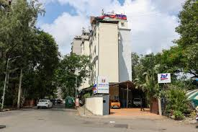
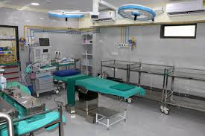

Location: Juhu-Versova Link Road
https://maps.app.goo.gl/QRzd3LxoTN3mek8U9

Rating: 4.4⭐
Contact: 022 3524 4700
Distance: 500m from RGIT
Website: https://thungasthhospital.com/index.html

- Bhartiya Arogya Nidhi Hospital

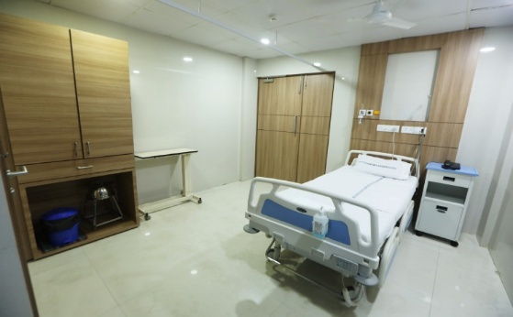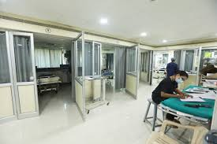

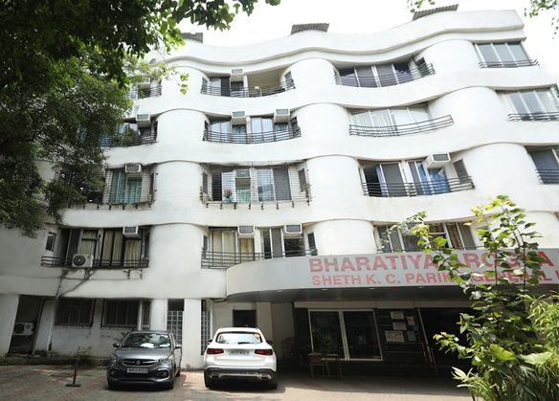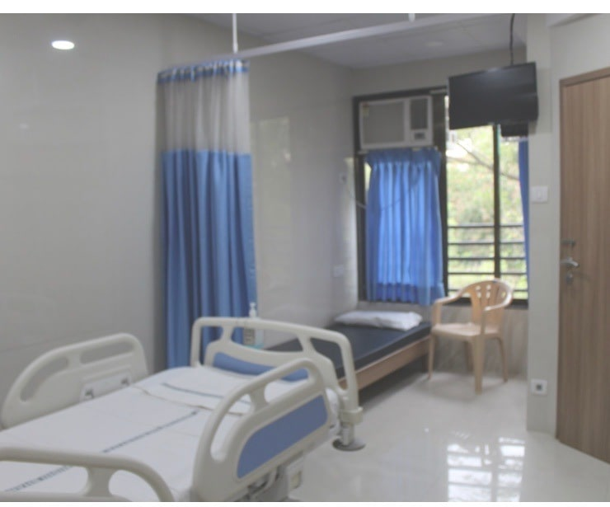

Location: JVPD, Vile Parle
https://maps.app.goo.gl/pehFUfPxucQiebHLA

Rating: 4.6⭐
Contact: 022 6948 6060
Distance: 2km from RGIT
Website: https://arogyanidhihospital.com

- Bellevue Multidisciplinary Hospital

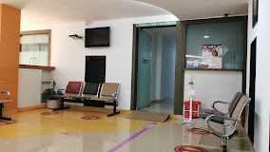
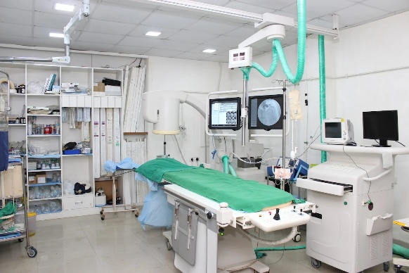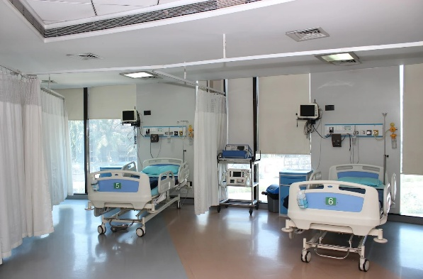

Location: DN Nagar Metro Station, Andheri West
https://maps.app.goo.gl/jtUX6hPwQaN2V8ez6

Rating: 3.4⭐
Contact: 022 6686 8600
Distance: 2km from RGIT
Website: https://bellevuemumbai.com

- BSES MG Hospital

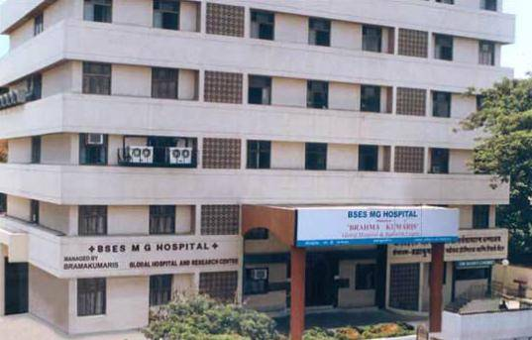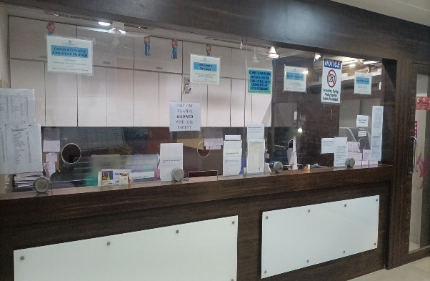

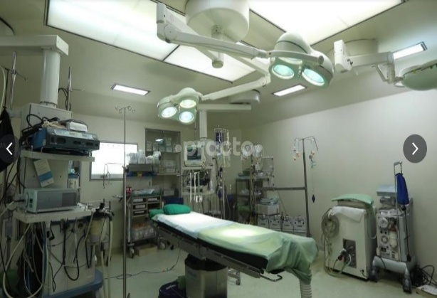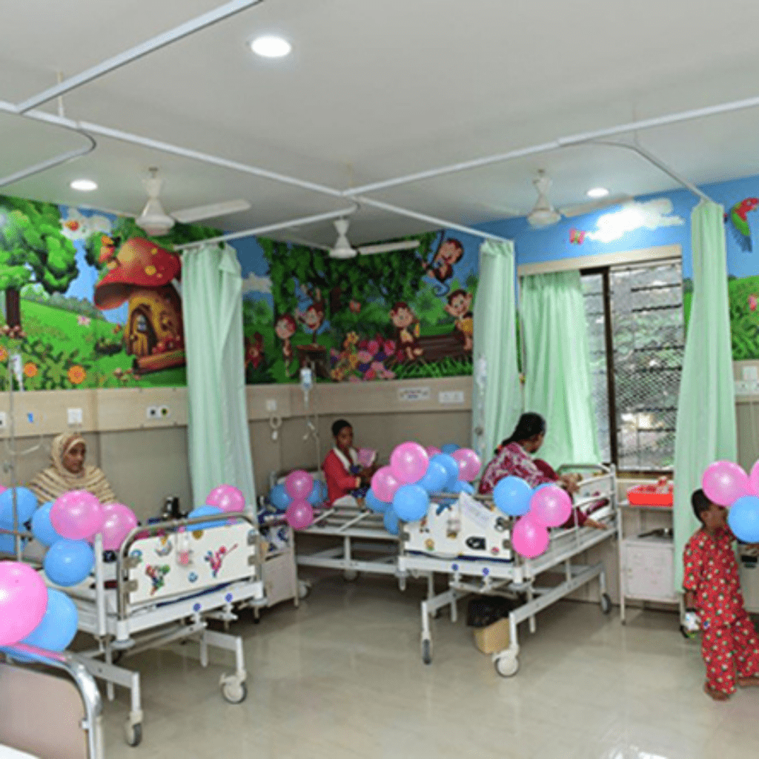

Location: Swami Vivekanand Road, Andheri West
https://maps.app.goo.gl/GxNypDLQ1qwkKgJS9

Rating: 3.4⭐
Contact: 022 6648 7500
Distance: 2.9km from RGIT
Website: https://www.ghrc-mum.org

- Dr. R.N. Cooper Municipal General Hospital

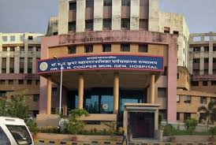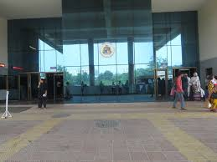
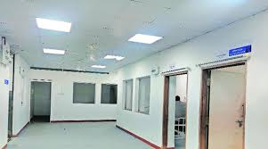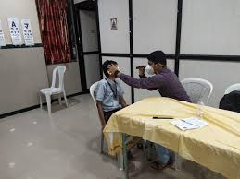

Location: Bhaktivedanta Swami Road, JVPD
https://maps.app.goo.gl/iWf5VDyaPchGj2Jx9

Rating: 3.0⭐
Contact: 022 2620 7254
Distance: 3.0km from RGIT
Website: https://hbtmc.edu.in

- Lion Kartar Singh Hospital

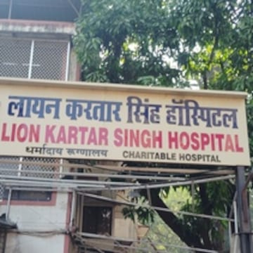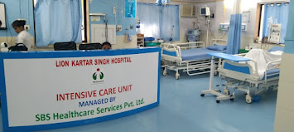

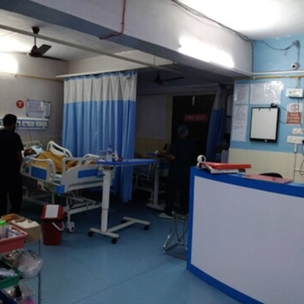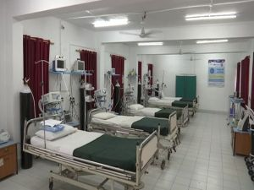

Location: Dadabhai Cross Rd, Andheri West
https://maps.app.goo.gl/zzAd9UPSN9uobpNc9

Rating: 4.6⭐
Contact: 098194 59288
Distance: 3.1km from RGIT
Website: NA

- KJ Cure Hospital

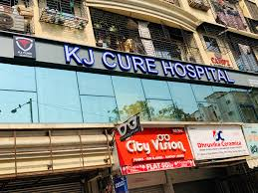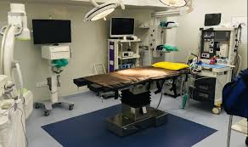

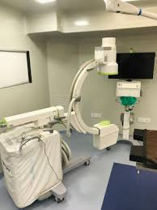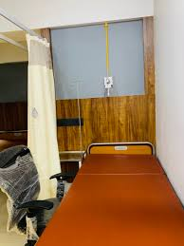

Location: Swami Vivekanand Road. Jogeshwari West
https://maps.app.goo.gl/uR18wCCrPT31AcMM7

Rating: 4.4⭐
Contact: 080976 02691
Distance: 3.8km from RGIT
Website: NA

Local Dispensaries

- Dr. Yogesh Jawale’s Clinic

Location: Versova Metro Station, Andheri West
Rating: 4.4⭐
Contact: 9833150531

- Dr. Sushrut Save/ Dr. Nitin Save’s Clinic

Location: Yashodhan Apartment, 4 Bungalows, Andheri West
Rating: 4.7⭐
Contact: 098192 99633

- Dr. Mangesh Jalgaonkar’s Clinic

Location: Veera Desai Road, Azad Nagar, Andheri West
Rating: 4.8⭐
Contact: 086557 01888

